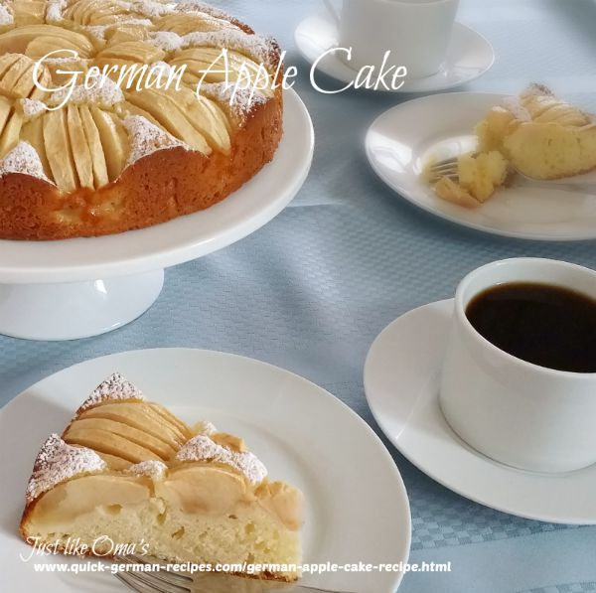

Apfelkuchen (German Apple Cake)
Ingredients:
- 3 - 5 apples
- 1/2 cup butter, room temperature
- 3/4 cup granulated sugar
- 2 eggs
- 1 tsp lemon juice
- 1 3/4 cup all-purpose flour
- 1 1/2 tsp baking powder
- 1/2 tsp salt
- 1/2 cup milk
- powdered sugar (icing sugar)
Instructions:
- Preheat oven to 350° F.
- Grease bottom and sides of a 10-inch springform pan.
- Peel, quarter, and core apples. Thinly slice each quarter several times without cutting all the way through. Do this just before you place them on cake. The apples "open" when they are baked.
- In a medium bowl, beat butter and sugar, eggs and lemon juice until creamy.
- Blend flour, baking powder, and salt. Stir into sugar mixture alternately with the milk.
- Spread batter in the pan. Arrange apple quarters as shown.
- Bake 50 to 55 minutes or until a wooden pick inserted in center comes out clean.
- Cool in pan on wire rack. Remove the cake from pan.
- Dust with powdered icing sugar just before serving. Put a tablespoon of powdered sugar into a small sieve. Gently strike the sieve with a spoon to sprinkle it evenly over cake.
Hints: Add 1/2 to 1 tsp almond flavoring instead of or as well as the lemon juice.

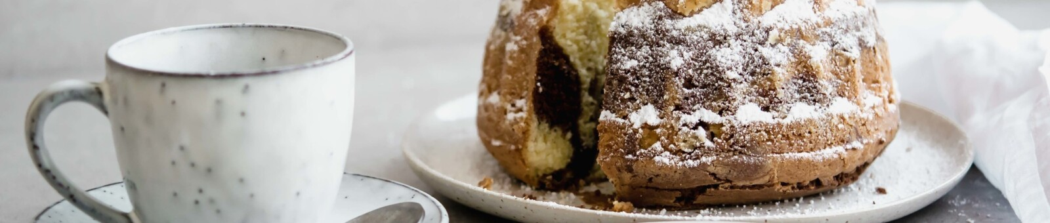

Marmorgugelhupf (Austrian Bundt Cake / Viennese Ring Cake)

3/4 cup unsalted butter
4 eggs, separated
2 1/2 cups flour
2/3 cup milk
2 1/2 cup confectioner’s sugar (plus more to decorate)
1 tsp vanilla extract
3/4 tsp baking powder
3-4 tsp cocoa

How to make it:

Step 1:
Preheat your oven to 170°C / 340°F and coat the bundt pan with melted butter.

Step 2:
Whisk the butter with the egg yolk until foamy, add confectioner’s sugar, and stir until creamy. Add vanilla extract.

Step 3:
Beat the egg whites until stiff. Sift together the flour and baking powder. Mix half of the flour into the butter mixture and combine. Add the milk, combine, then add remainder of the flour.
Pour less than half of this mixture into the pan. Add cocoa to the rest and mix. Pour the darker batter on top of the lighter one into the pan.

Step 4:
Drag the handle of a wooden spoon or a regular fork through the batter in a wave-like motion to achieve the marble texture.
Bake for 50 to 55 minutes. Let cool for a few minutes, then take the cake out of the pan. Dust with confectioner’s sugar.

Preparation time: 70 minutes

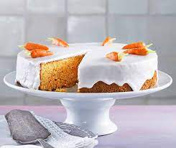
Rüeblikueche (Swiss Carrot Cake)

Ingredients:
- 1 ¼ Cup Sugar
- 5 Egg yolks
- 2 Tbsp Hot water
- 2 ¾ Cups Carrots, finely grated
- 2 ¼ Cups Ground almonds
- 1 Lemon, grated peel and juice
- ⅔ Cup Flour
- 2 tsp Baking powder
- 5 Egg whites
- 1 pinch Salt
Frosting
- 2 ½ Cups Powdered sugar
- 2 Tbsp Cherry or lemon juice
- 2 Tbsp Water

Instructions:
- Heat the oven to 350 degrees.
- Mix the sugar, egg yolks and water in a bowl with a stand or hand mixer for approx. 5 minutes until foamy.
- Add the carrots, ground almonds, lemon peel and lemon juice into the mixture.
- Mix the flour and baking powder together, then add to the batter mixture.
- Beat the egg whites with the salt until stiff and carefully fold them into the mixture using a rubber spatula. Pour the batter into the cake form
- Bake approx. 55 minutes in the lower half of the oven. Remove from the oven, cool slightly. Place the cake onto a wire rack and let it cool.
- Place the cake on baking paper. Then make the frosting by mixing the powdered sugar, juice and water well, and pouring it onto the middle of the cake, letting it flow over the surface and the edges to ensure it covers all of the cake.

For the State German Convention, do not place decorative carrot shapes on top of the cake as shown in the picture.

Bretzeln (Pretzels)

2 TBS hot Water 110 F
1 TBS dry yeast
1 ⅓ Cup warm water 80-90 F
⅓ C brown Sugar
5 Cups Flour
Salt flakes

4-5 TBS Baking Soda
4-5 Cups water

Mix hot water and yeast.
Stir in warm water and brown sugar.
Slowly add 5 cups of Flour, stirring immediately.
Knead dough for 5-7 minutes

Let rise 10-15 minutes

Grease cookie pan, line with parchment paper.

Fill pot with water. Add 1TBS baking soda for every cup of water.
Bring water to gentle boil.

Pinch off golf ball sized pieces of dough.
Shape as desired.

Lower pretzels into baking soda bath for 30 seconds.

Place on a lined baking sheet.

Top with large salt.

Cook at 475 for 9 minutes.

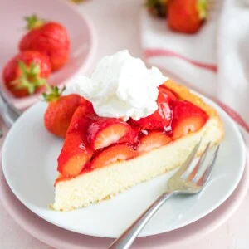
Erdbeerkuchen (Strawberry Cake)

Ingredients for the Cake
- 4 large eggs room temperature
- ¾ cup granulated white sugar
- 1 cup all-purpose flour
- ½ cup vegetable oil neutral
- 1 ½ tsp baking powder
- 1 tsp vanilla sugar or vanilla extract

Ingredients for the topping
- ½ tsp whip-it whipped cream stabilizer see alternatives below
- 1 pound strawberries
- 1 package red glaze prepared according to package

Instructions
- Preheat the oven to 350°F (180°C) and grease the pan (an 11-inch tart pan if possible) with butter or baking spray.
- In the bowl of a stand mixer using the paddle attachment, combine sugar and eggs. Mix for 1 minute at medium speed then add all remaining ingredients and mix for 1.5 minutes at medium-high speed.
- Transfer the batter to the prepared pan and tap the pan on the counter a few times to make sure no big air bubbles are in the batter.
- Bake for 25-30 minutes, until a toothpick comes out clean with only a few crumbs attached. Rotate the pan after 10 minutes.
- Let the cake cool for a few minutes before carefully removing it from the pan then transfer it to a wire rack to cool completely.
- When the cake is cool, sprinkle it lightly with whip-it powder (see alternatives below) then hull the strawberries, half them, and arrange them on top of the cake. Filling holes with smaller strawberries.
- Prepare the glaze according to package directions then spoon it over the fruit making sure everything is covered. Let the glaze set then serve with whipped cream.

Notes
- You need a special tart pan for this recipe. It has a rim at the bottom that later holds the filling.
- Make sure the tart pan is greased well so the cake easily comes out of the pan after baking
- It's important that the eggs are at room temperature so the cake gets airy and not dry. Take them out of the fridge an hour before you need them or put them in a bowl of warm water for 15 minutes
- Tap the pan on the counter a few times so the big air bubbles that might be in the batter burst or you might end up with holes in the baked cake
- If big air bubbles show up during baking use a toothpick to pop them
- Instead of "whip-it" whipped cream stabilizer which I use so the fruit juices don't make the cake soggy, you can also use a light sprinkle of ground nuts or even a layer of cooked vanilla pudding. If you serve the cake within a few hours of making you can also just omit it and put the strawberries directly on top of the cake
- Make sure the strawberries are facing outside up on the cake. This gives you a better look but also keeps the fruit fresh longer
- The glaze needs to cover all the berries! I use a spoon to spoon it over the berries instead of just pouring it over the cake
- The glaze sets within a few minutes so you need to work fast
- Instead of using a glaze, you can also use apricot preserves or any lightly colored jelly. Heat up half a cup of the preserves or jelly just until warm, stir until it is smooth, and then brush over the berries.

